**WEEK-7**

**REACTJS-HOL**

**Exercise-9:** **Create a React Application named “cricketapp”**

**App.js:**

import React, { useState } from "react";

import ListofPlayers from "./ListofPlayers";

import IndianPlayers from "./IndianPlayers";

function App() {

  const [flag, setFlag] = useState(false);

  return (

    <div className="App">

      <button onClick={() => setFlag(!flag)}>Toggle View</button>

      {flag ? <ListofPlayers /> : <IndianPlayers />}

    </div>

  );

}

export default App;

**ListofPlayers.js:**

import React from "react";

const players = [

  { name: "Mr. Jack", score: 50 },

  { name: "Mr. Michael", score: 70 },

  { name: "Mr. John", score: 40 },

  { name: "Mr. Ann", score: 61 },

  { name: "Mr. Elisabeth", score: 61 },

  { name: "Mr. Sachin", score: 95 },

  { name: "Mr. Dhoni", score: 100 },

  { name: "Mr. Virat", score: 84 },

  { name: "Mr. Jadeja", score: 64 },

  { name: "Mr. Raina", score: 75 },

  { name: "Mr. Rohit", score: 80 },

];

function ListofPlayers() {

  const allPlayers = players.map((player) => (

    <li key={player.name}>{player.name} {player.score}</li>

  ));

  const lowScoringPlayers = players

    .filter((player) => player.score < 70)

    .map((player) => (

      <li key={player.name}>{player.name} {player.score}</li>

    ));

  return (

    <div>

      <h2>List of Players</h2>

      <ul>{allPlayers}</ul>

      <h2>List of Players having Scores Less than 70</h2>

      <ul>{lowScoringPlayers}</ul>

    </div>

  );

}

export default ListofPlayers;

**IndianPlayers.js:**

import React from "react";

function IndianPlayers() {

  const oddPlayers = ["Sachin1", "Virat3", "Yuvaraj5"];

  const evenPlayers = ["Dhoni2", "Rohit4", "Raina6"];

  const T20Players = [

    "Mr. First Player",

    "Mr. Second Player",

    "Mr. Third Player",

  ];

  const RanjiPlayers = [

    "Mr. Fourth Player",

    "Mr. Fifth Player",

    "Mr. Sixth Player",

  ];

  const mergedPlayers = [...T20Players, ...RanjiPlayers];

  return (

    <div>

      <h2>Odd Players</h2>

      <ul>

        <li>First : {oddPlayers[0]}</li>

        <li>Third : {oddPlayers[1]}</li>

        <li>Fifth : {oddPlayers[2]}</li>

      </ul>

      <h2>Even Players</h2>

      <ul>

        <li>Second : {evenPlayers[0]}</li>

        <li>Fourth : {evenPlayers[1]}</li>

        <li>Sixth : {evenPlayers[2]}</li>

      </ul>

      <h2>List of Indian Players Merged:</h2>

      <ul>

        {mergedPlayers.map((player) => (

          <li key={player}>{player}</li>

        ))}

      </ul>

    </div>

  );

}

export default IndianPlayers;

**App.css:**

.App {

  text-align: center;

}

.App-logo {

  height: 40vmin;

  pointer-events: none;

}

@media (prefers-reduced-motion: no-preference) {

  .App-logo {

    animation: App-logo-spin infinite 20s linear;

  }

}

.App-header {

  background-color: #282c34;

  min-height: 100vh;

  display: flex;

  flex-direction: column;

  align-items: center;

  justify-content: center;

  font-size: calc(10px + 2vmin);

  color: white;

}

.App-link {

  color: #61dafb;

}

@keyframes App-logo-spin {

  from {

    transform: rotate(0deg);

  }

  to {

    transform: rotate(360deg);

  }

}

**OUTPUT:**

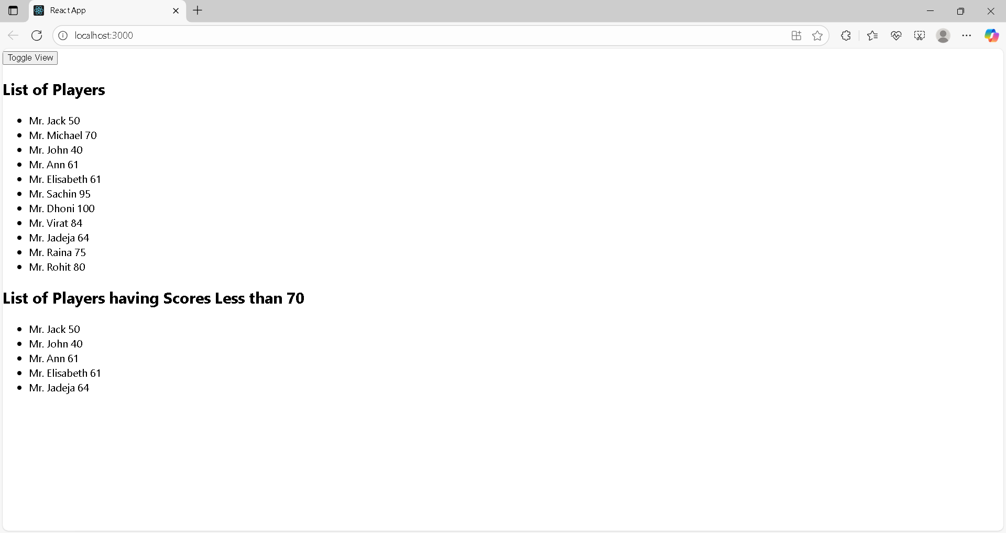

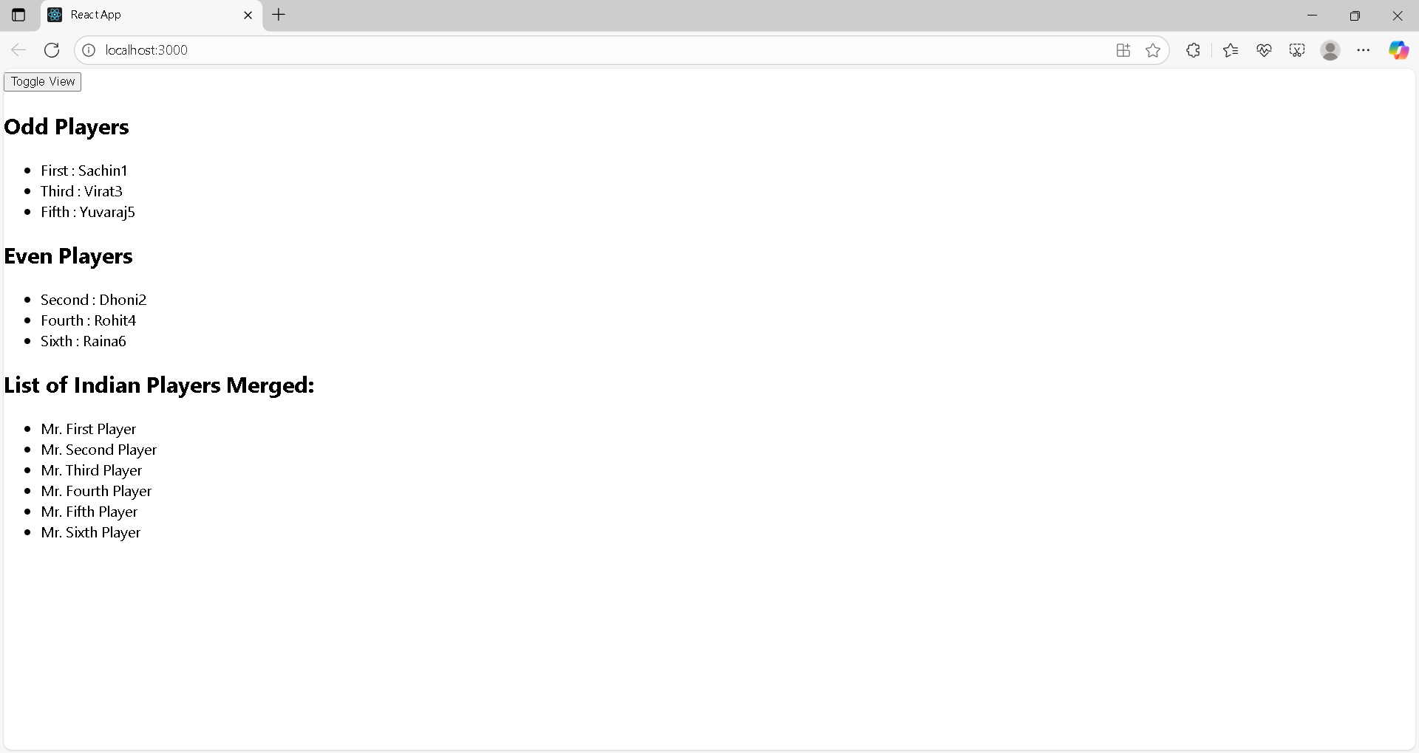

**Exercise-10:** **Create a React Application named “officespacerentalapp”**

**App.js:**

import React from "react";

function App() {

  const heading = <h1>Office Space , at Affordable Range</h1>;

  const image = (

    <img

      src="/dbs-bank-offices.jpg"

      alt="Office Space"

      width="300"

      height="200"

    />

  );

  const office = {

    name: "DBS",

    rent: 50000,

    address: "Chennai",

  };

  return (

    <div style={{ padding: "20px" }}>

      {heading}

      {image}

      <h2>Name: {office.name}</h2>

      <p>

        <strong style={{ color: office.rent < 60000 ? "red" : "green" }}>

          Rent: Rs. {office.rent}

        </strong>

      </p>

      <p>

        <strong>Address:</strong> {office.address}

      </p>

    </div>

  );

}

export default App;

**OUTPUT:**

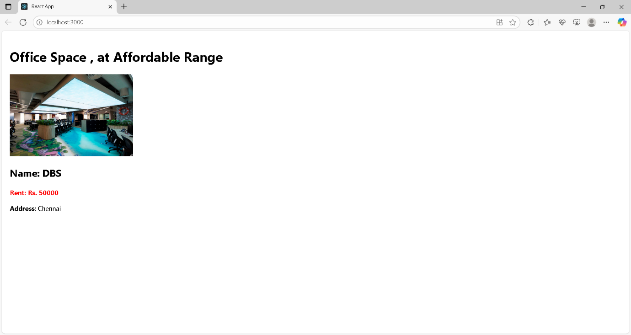

**Exercise-11:** **Create a React Application “eventexamplesapp” to handle various events of the form elements in HTML.**

**App.js:**

import React, { Component } from "react";

import CurrencyConvertor from "./CurrencyConvertor";

class App extends Component {

  constructor(props) {

    super(props);

    this.state = {

      count: 5,

    };

    this.sayWelcome = this.sayWelcome.bind(this);

    this.handleClick = this.handleClick.bind(this);

  }

  increment = () => {

    this.setState({ count: this.state.count + 1 });

    alert("Hello! Member1");

  };

  decrement = () => {

    this.setState({ count: this.state.count - 1 });

  };

  sayWelcome(msg) {

    alert(msg);

  }

  handleClick(event) {

    alert("I was clicked");

  }

  render() {

    return (

      <div style={{ padding: "20px" }}>

        <h2>{this.state.count}</h2>

        <button onClick={this.increment}>Increment</button>

        <br /><br />

        <button onClick={this.decrement}>Decrement</button>

        <br /><br />

        <button onClick={() => this.sayWelcome("welcome")}>Say welcome</button>

        <br /><br />

        <button onClick={this.handleClick}>Click on me</button>

        <br /><br />

        <CurrencyConvertor />

      </div>

    );

  }

}

export default App;

**CurrencyConvertor.js:**

import React, { Component } from "react";

class CurrencyConvertor extends Component {

  constructor(props) {

    super(props);

    this.state = {

      amount: "",

      currency: "",

    };

  }

  handleChange = (e) => {

    this.setState({ amount: e.target.value });

  };

  handleSubmit = () => {

    const amount = parseFloat(this.state.amount);

    const rupees = amount * 80; // Example conversion rate

    this.setState({ currency: "Euro" });

    alert("Converting to Euro Amount is " + rupees);

  };

  render() {

    return (

      <div>

        <h2 style={{ color: "green" }}>Currency Convertor!!!</h2>

        <label>Amount: </label>

        <input type="text" value={this.state.amount} onChange={this.handleChange} /><br /><br />

        <label>Currency: </label>

        <textarea value={this.state.currency} readOnly></textarea><br /><br />

        <button onClick={this.handleSubmit}>Submit</button>

      </div>

    );

  }

}

export default CurrencyConvertor;

**OUTPUT:**

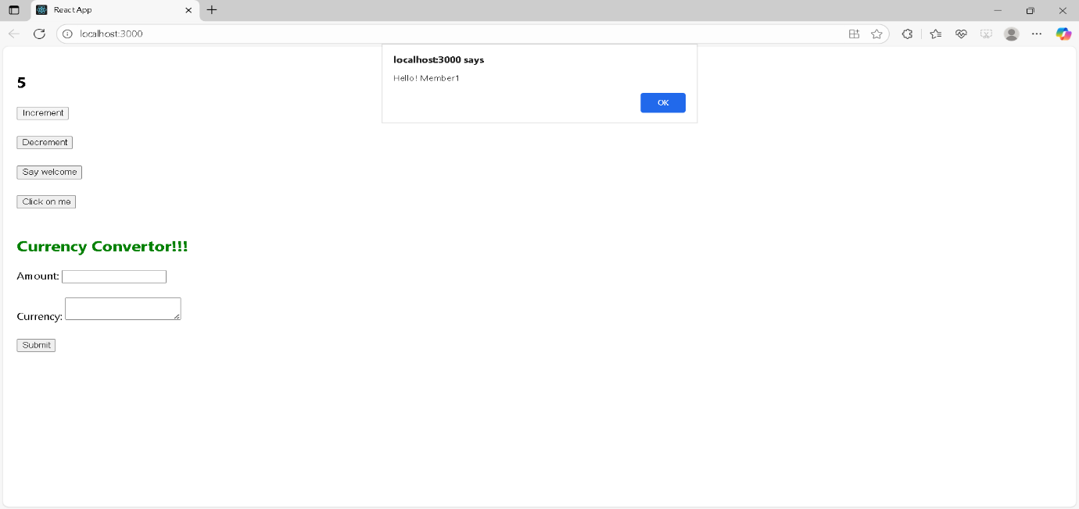

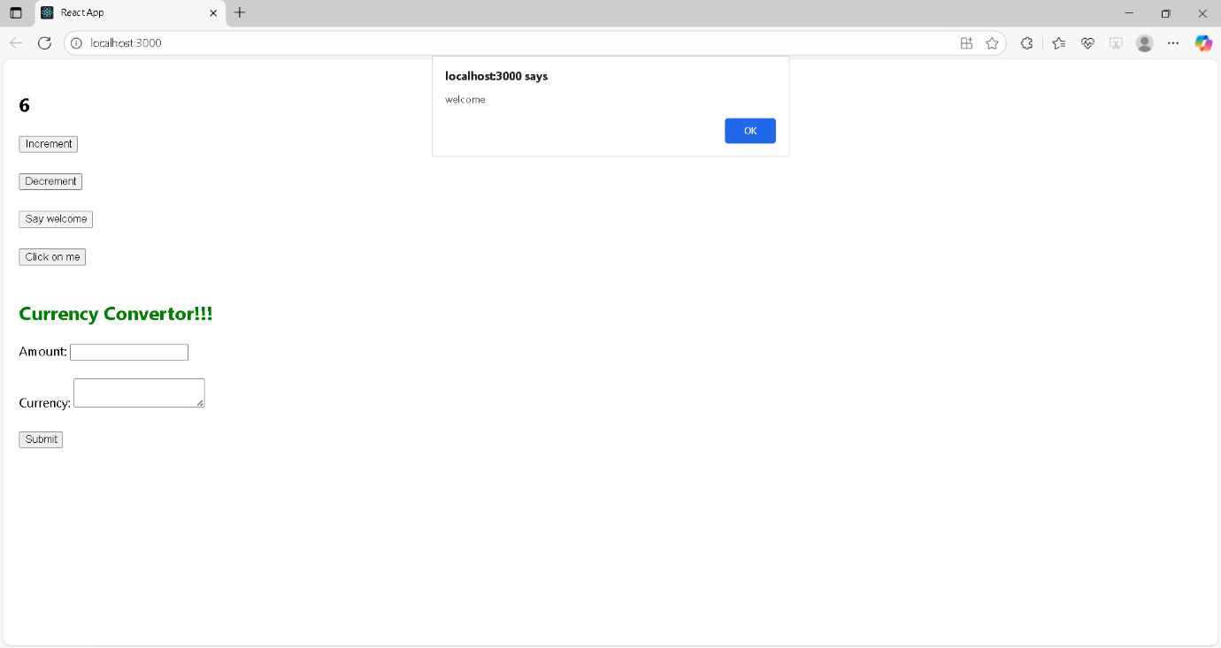

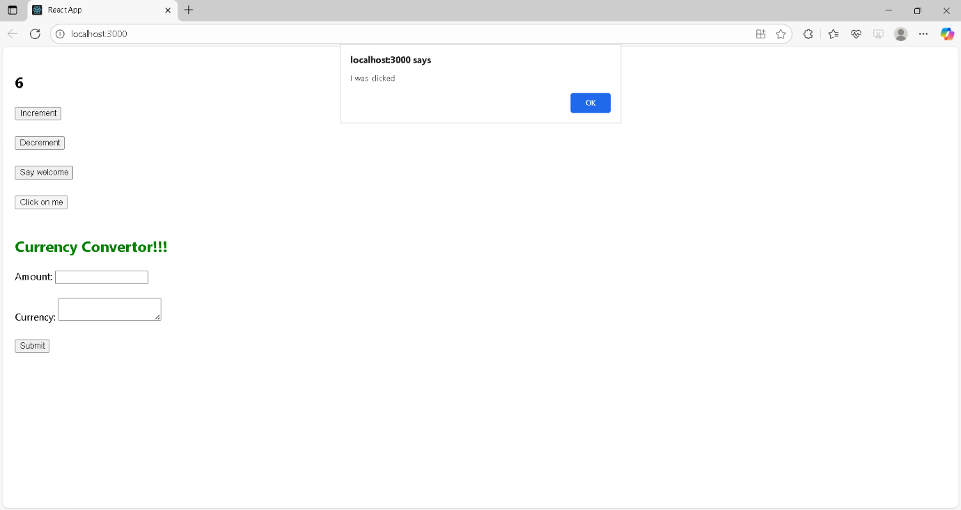

**Exercise-12:** **Create a React Application named “ticketbookingapp” where the guest user can browse the page where the flight details are displayed whereas the logged in user only can book tickets.**

**App.js:**

import React, { Component } from "react";

import Greeting from "./Greeting";

import LoginButton from "./LoginButton";

import LogoutButton from "./LogoutButton";

class App extends Component {

  constructor(props) {

    super(props);

    this.state = { isLoggedIn: false };

  }

  handleLoginClick = () => {

    this.setState({ isLoggedIn: true });

  };

  handleLogoutClick = () => {

    this.setState({ isLoggedIn: false });

  };

  render() {

    const isLoggedIn = this.state.isLoggedIn;

    let button;

    if (isLoggedIn) {

      button = <LogoutButton onClick={this.handleLogoutClick} />;

    } else {

      button = <LoginButton onClick={this.handleLoginClick} />;

    }

    return (

      <div>

        <Greeting isLoggedIn={isLoggedIn} />

        {button}

      </div>

    );

  }

}

export default App;

**Greeting.js:**

import React from "react";

function UserGreeting() {

  return <h1>Welcome back</h1>;

}

function GuestGreeting() {

  return <h1>Please sign up.</h1>;

}

function Greeting(props) {

  const isLoggedIn = props.isLoggedIn;

  if (isLoggedIn) {

    return <UserGreeting />;

  }

  return <GuestGreeting />;

}

export default Greeting;

**LoginButton.js:**

import React from "react";

function LoginButton(props) {

  return <button onClick={props.onClick}>Login</button>;

}

export default LoginButton;

**LogoutButton.js:**

import React from "react";

function LogoutButton(props) {

  return <button onClick={props.onClick}>Logout</button>;

}

export default LogoutButton;

**OUTPUT:**

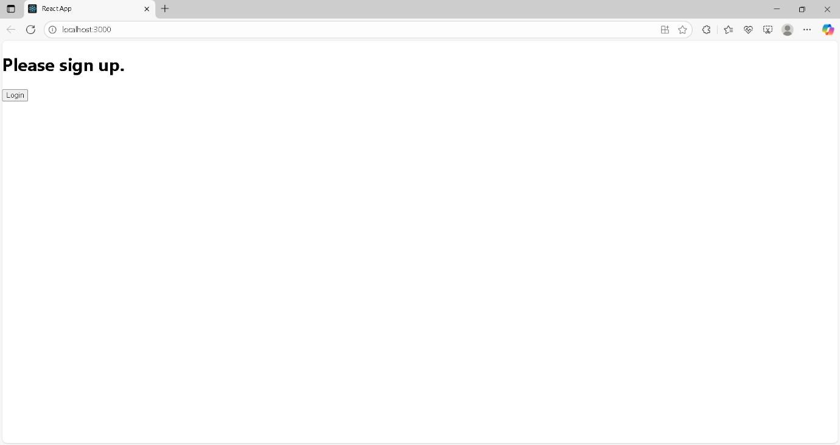

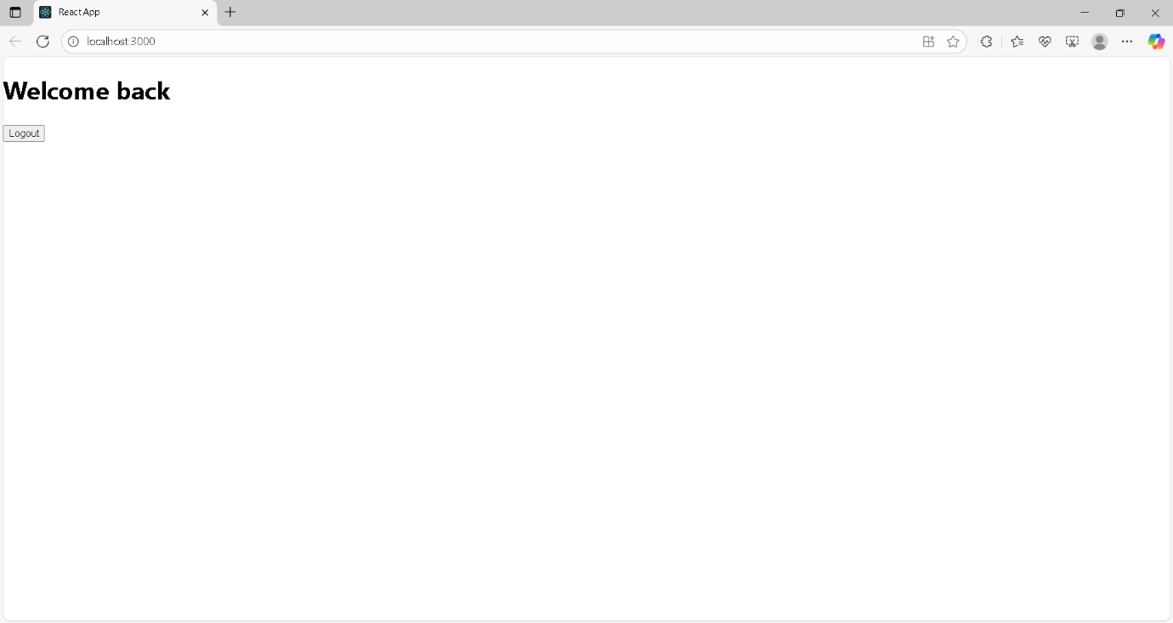

**Exercise-13:** Create a React App named “bloggerapp” in with 3 components.

**App.js:**

import React from "react";

function BlogDetails() {

  const blogs = [

    {

      title: "React Learning",

      author: "Stephen Biz",

      content: "Welcome to learning React!",

    },

    {

      title: "Installation",

      author: "Schwezdnier",

      content: "You can install React from npm.",

    },

  ];

  return (

    <div

      style={{

        borderLeft: "3px solid green",

        paddingLeft: "20px",

        fontFamily: "Segoe UI, Tahoma, Geneva, Verdana, sans-serif",

      }}

    >

      <h2>Blog Details</h2>

      {blogs.map((blog, index) => (

        <div key={index}>

          <h3>{blog.title}</h3>

          <p>

            <strong>{blog.author}</strong>

          </p>

          <p>{blog.content}</p>

        </div>

      ))}

    </div>

  );

}

export default BlogDetails;

**BookDetails.js:**

import React from "react";

function BookDetails() {

  const books = [

    { name: "Master React", price: 670 },

    { name: "Deep Dive into Angular 11", price: 800 },

    { name: "Mongo Essentials", price: 450 },

  ];

  return (

    <div

      style={{

        borderLeft: "3px solid green",

        paddingLeft: "20px",

        fontFamily: "Segoe UI, Tahoma, Geneva, Verdana, sans-serif",

      }}

    >

      <h2>Book Details</h2>

      {books.map((book, index) => (

        <div key={index}>

          <h3>{book.name}</h3>

          <p>{book.price}</p>

        </div>

      ))}

    </div>

  );

}

export default BookDetails;

**BlogDetails.js:**

import React from "react";

function BlogDetails() {

  const blogs = [

    {

      title: "React Learning",

      author: "Stephen Biz",

      content: "Welcome to learning React!",

    },

    {

      title: "Installation",

      author: "Schwezdnier",

      content: "You can install React from npm.",

    },

  ];

  return (

    <div

      style={{

        borderLeft: "3px solid green",

        paddingLeft: "20px",

        fontFamily: "Segoe UI, Tahoma, Geneva, Verdana, sans-serif",

      }}

    >

      <h2>Blog Details</h2>

      {blogs.map((blog, index) => (

        <div key={index}>

          <h3>{blog.title}</h3>

          <p>

            <strong>{blog.author}</strong>

          </p>

          <p>{blog.content}</p>

        </div>

      ))}

    </div>

  );

}

export default BlogDetails;

**CourseDetails.js:**

import React from "react";

function CourseDetails() {

  const courses = [

    { name: "Angular", date: "4/5/2021" },

    { name: "React", date: "6/3/20201" },

  ];

  return (

    <div style={{ fontFamily: "Segoe UI, Tahoma, Geneva, Verdana, sans-serif" }}>

      <h2>Course Details</h2>

      {courses.map((course, index) => (

        <div key={index}>

          <h3>{course.name}</h3>

          <p>{course.date}</p>

        </div>

      ))}

    </div>

  );

}

export default CourseDetails;

**OUTPUT:**

